HD 213472

HD 213472 is a 1.048 M☉, G5 star1. Based on 61 RV HIRES measurements obtained between 2001 and 2019, the CL survey reported a LPGP with a period of days, a minimum mass of MJup and an eccentricity of .

In the present study, in addition to the CL survey’s dataset, 1 RV ELODIE measurements obtained in November 2004 and 4 RV SOPHIE measurements obtained between 2006 and 2015 were used. DPASS and MCMC (1000 walkers and 500000 iterations) to fit the data. With DPASS, a LPGP was found with a period of 21660 days, a minimum mass of 4.2 MJup and an eccentricity of 0.14, with a corresponding rms of residuals of 4.3 m/s. As the RV curve of HD 213472b covers neither minimum nor maximum, the stellar offset and therefore the properties of HD 213472b are actually not constrained at all. Thus, with MCMC, a flat distribution of the sampling is found for the minimum mass with values between 4 MJup and 1 M☉ without changing significantly the log-likelihood. The period (resp. eccentricity) is also poorly constrained with values between 128500 and 660000 days (resp. larger than 0.42).

To explore the range of possible values for these parameters, the stellar offset or the semi-major axis was fixed to different values and the data fitted with DPASS. The solutions associated with a rms of the residuals close to 3.7 m/s were considered as potential solutions. It is observed that all solutions with a semi-major axis greater than 9 au and a minimum mass greater than 3 Mjup could be acceptable.

The fits are shown in Fig 1, and the corner plot in Fig 2, and the results summarized in Table 1.

Conclusion: The properties found in the CL survey for HD 213472b are not confirmed. Depending on its semi-major axis and/or the stellar RV offset, the companion could be a brown dwarf. Additional data are needed to further constrain its orbital properties.

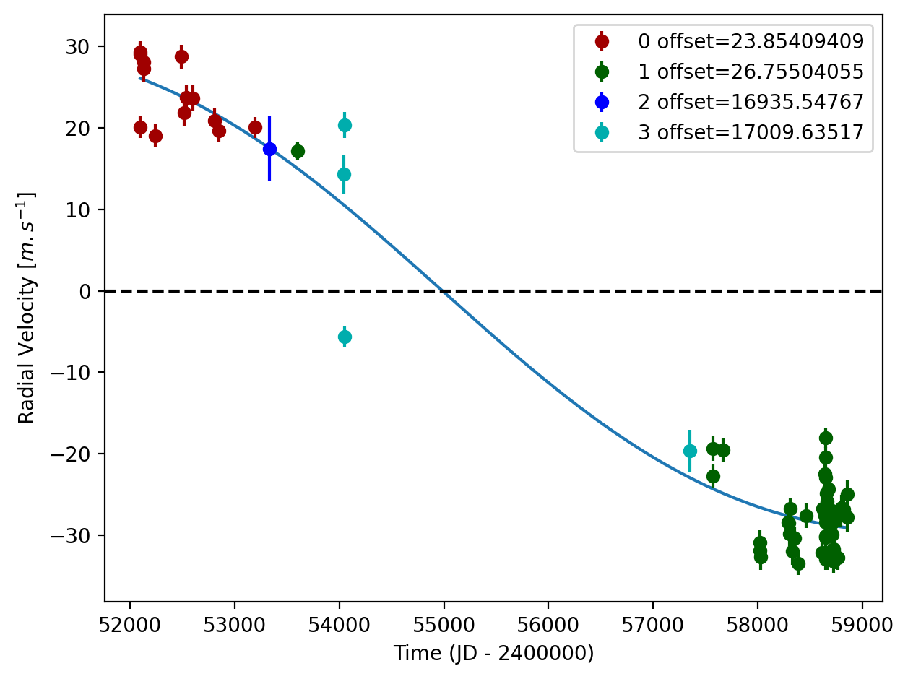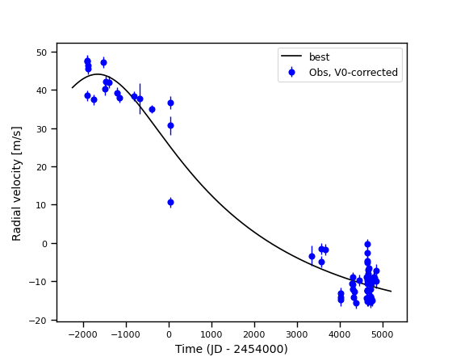

Figure 1: Left: fit of the HD 213472 RV with DPASS. Red - Hir94, green - Hir04, blue - ELODIE, cyan - SOPHIE. The blue curve shows the best fit. Right: fit of the HD 213472 RV using MCMC. The black curve shows the fit found with the best log-likelihood.

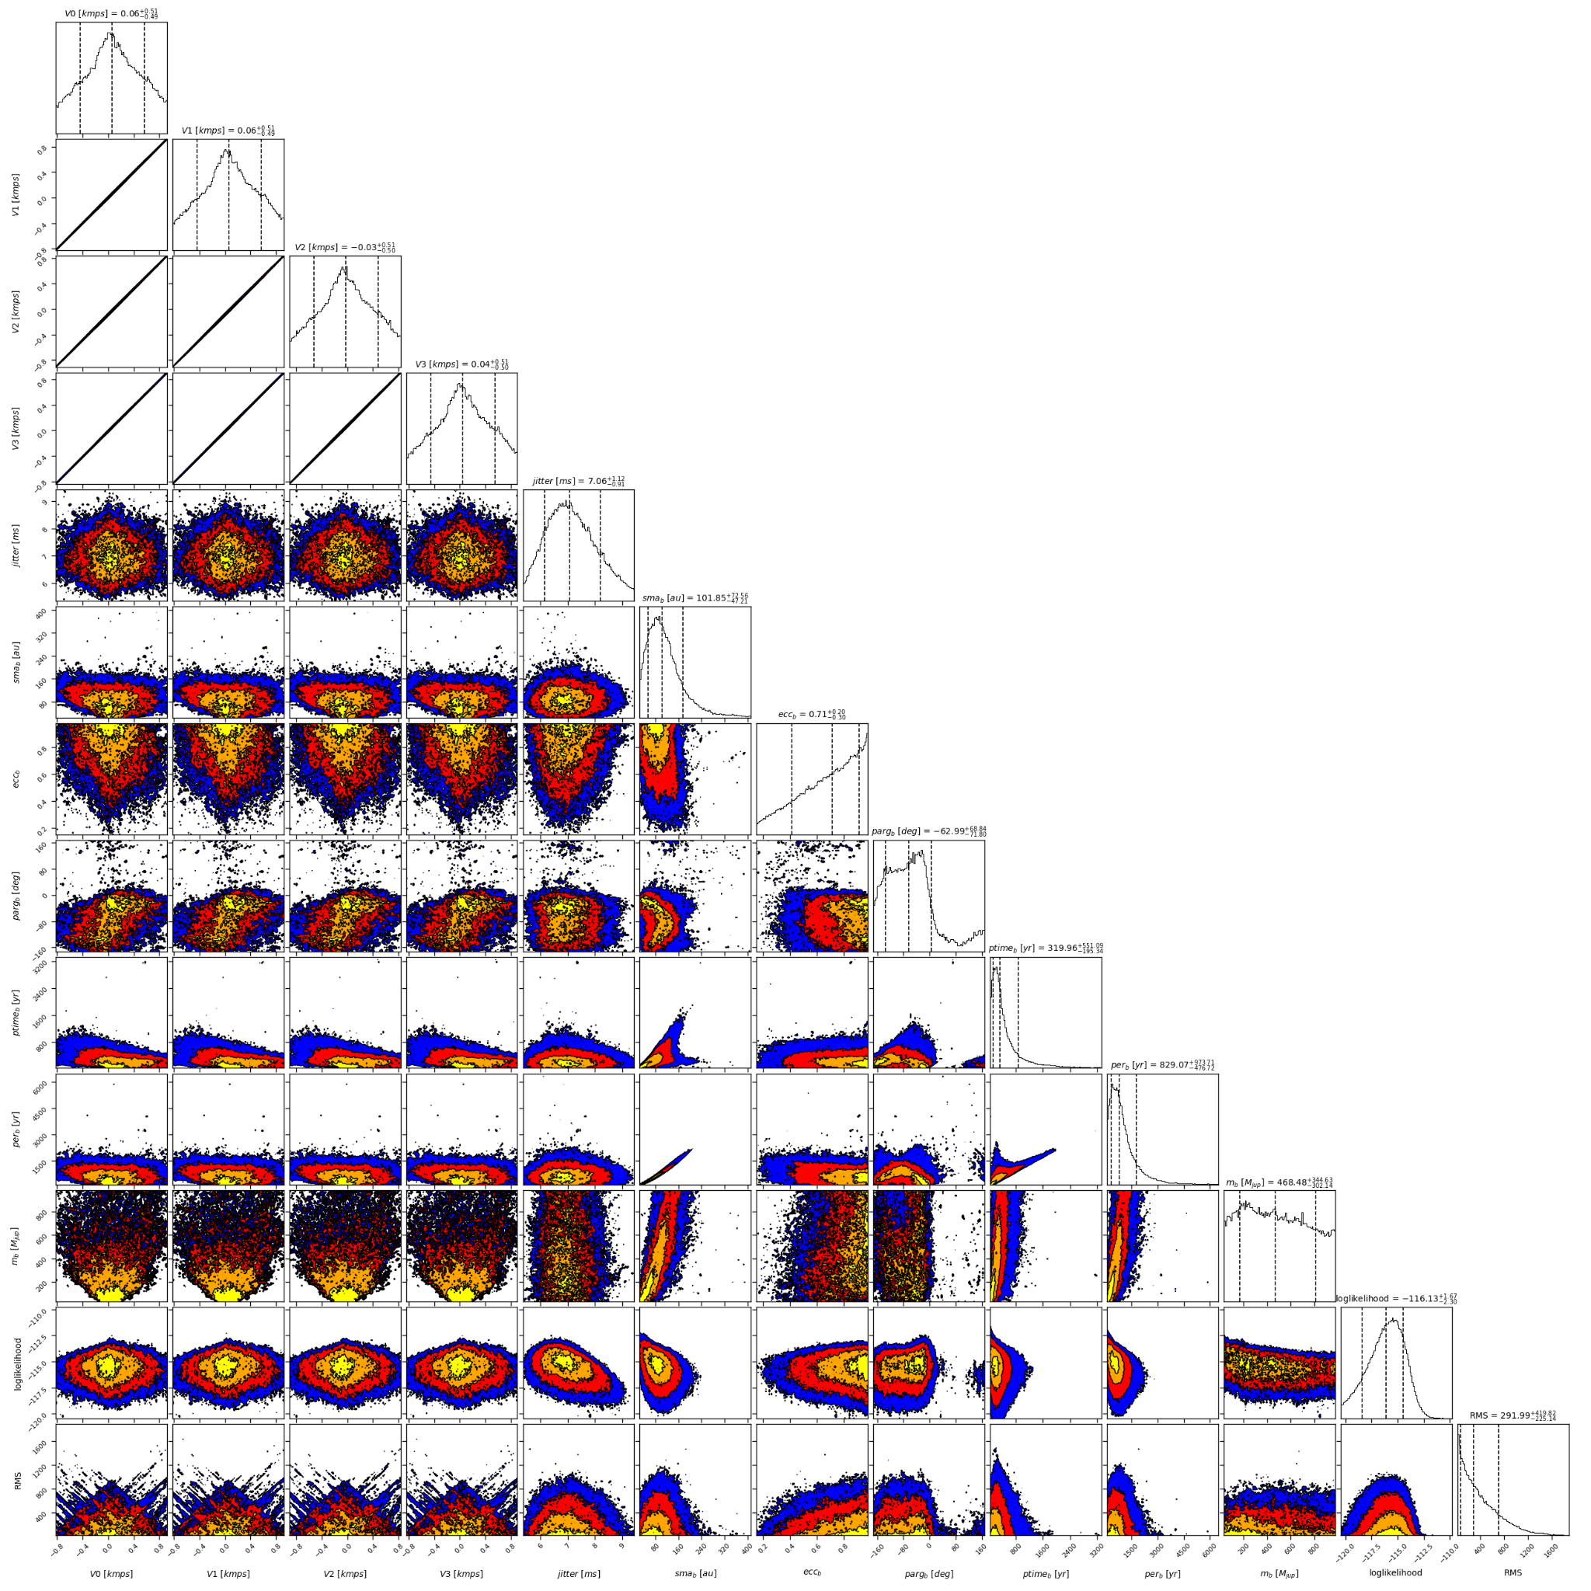

Figure 2: Corner plot of posteriors for the one-planet model MCMC fit of HD 213472 RV data.

| Parameter | Priors | | Posteriors | | CL survey |
| --- | --- | --- | --- | --- | --- |
|  | DPASS | MCMC | DPASS | MCMC |  |
| *a* (au) | [5,100] | [1,1000] | 15.5 | 54 – 174 |  |
| Msin(i) (MJup) | [0,100] | [0.5,1000] | 4.2 | 4 – 813 |  |
| Eccentricity | [0,0.8] | [0,0.99] | 0.14 | > 0.42 |  |
| Instrumentals offsets (km/s) | [-60,60] | [-1,1] | Hir94: 0.024  Hir04: 0.027  ELODIE: 16.936  SOPHIE: 17.010 | Hir94: -0.437 – 0.566  Hir04: -0.437 – 0.568  ELODIE: -0.525 – 0.480  SOPHIE: -0.454 – 0.552 |  |
| Stellar jitter (m/s) | [0,40] | [0,50] | 5.9 |  |  |
| Argument of periastron (°) | [0,360] | [-180,180] | 89 | 255 – 6 |  |
| Phase | [0,1] | [0,1] | 0.54 | 0.20 – 0.82 |  |

Table 1: HD 213472. Summary of priors and posteriors obtained with DPASS and MCMC, compared to the properties reported by the CL Survey.

References

1. Rosenthal, L. et al. The California Legacy Survey. I. A Catalog of 178 Planets from Precision Radial Velocity Monitoring of 719 Nearby Stars over Three Decades. *Astrophys. J.* *Suppl. Ser.* 255, 8 (2021).